**Static Model (older report) Dimitrije Prosevski 3D Game Design**

My static model is a car (Audi). It has body as one object, and 4 tires that are attached as children to the body. I built the body of the car using extrusion, rotation, scaling, translation. Details were added using UV editing from the image of car’s front, top, back, and sides. Rubber part of the tires is made using torus and given black material color. I learned a lot. I finally fully understand how UV modeling works and how blender controls behave, it took a while to get used to all the commands. If I could start again it would have many improvements. I am expecting to improve my scene for the next project with more details, smoother corners and better UV rendering. Possibly adding animation to it too.

**High quality render scene:**

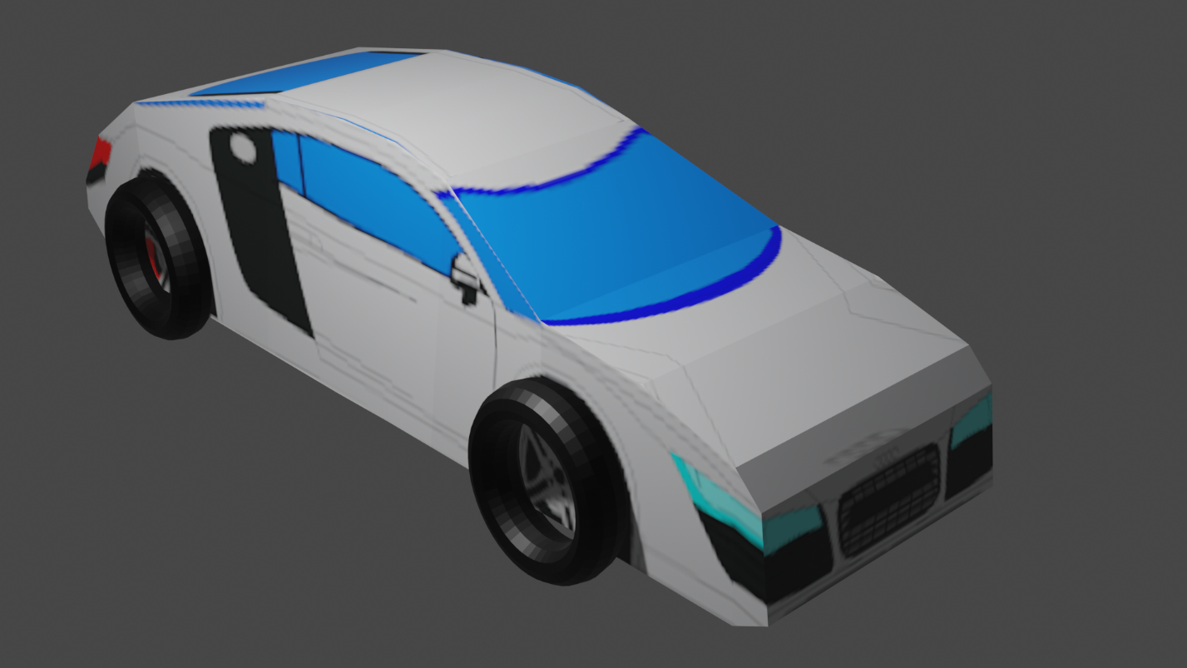

**Dynamic Model Dimitrije Prosevski 3D Game Design**

* **incorporate one or more custom meshes**

Created a car mesh used copy, extrude and UV mapping

* **include a baked procedural texture**

baked a brick material + magic color + color ramp for the plane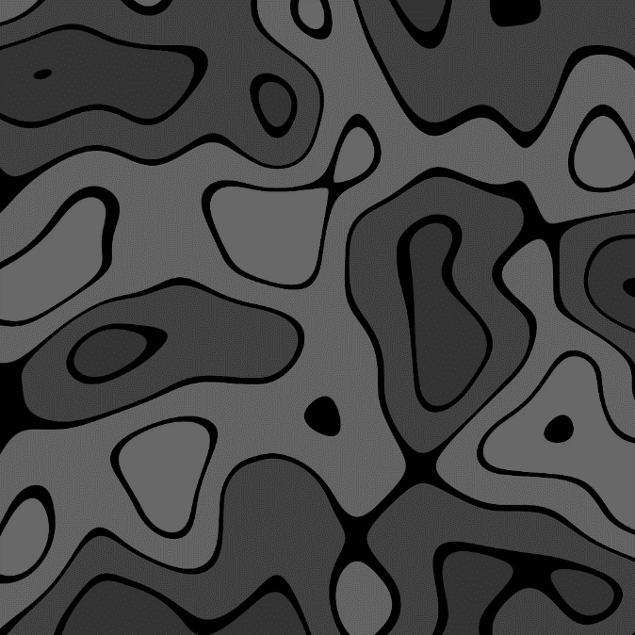

* **include an animation (walk cycle, moving object)**

car moves forwards, backwards, left and right

* **have some type of user interaction**

car movement using W, S, A, D keys.

* **Please include at least one custom haxe script**

DynamicModel\Sources\arm\node\MyKeyboardOpt.hx

* **You may also use logic nodes for other behaviors**

Implementation of movement mentioned above is done using logic nodes

* **Incorporate some type of physics simulation**

Gravity, car movement speed